**Crop management Breeding Trials**

Just make a simple report:

Enter: researcher name: and Month it will give all the trials done by that researcher on that particular month:

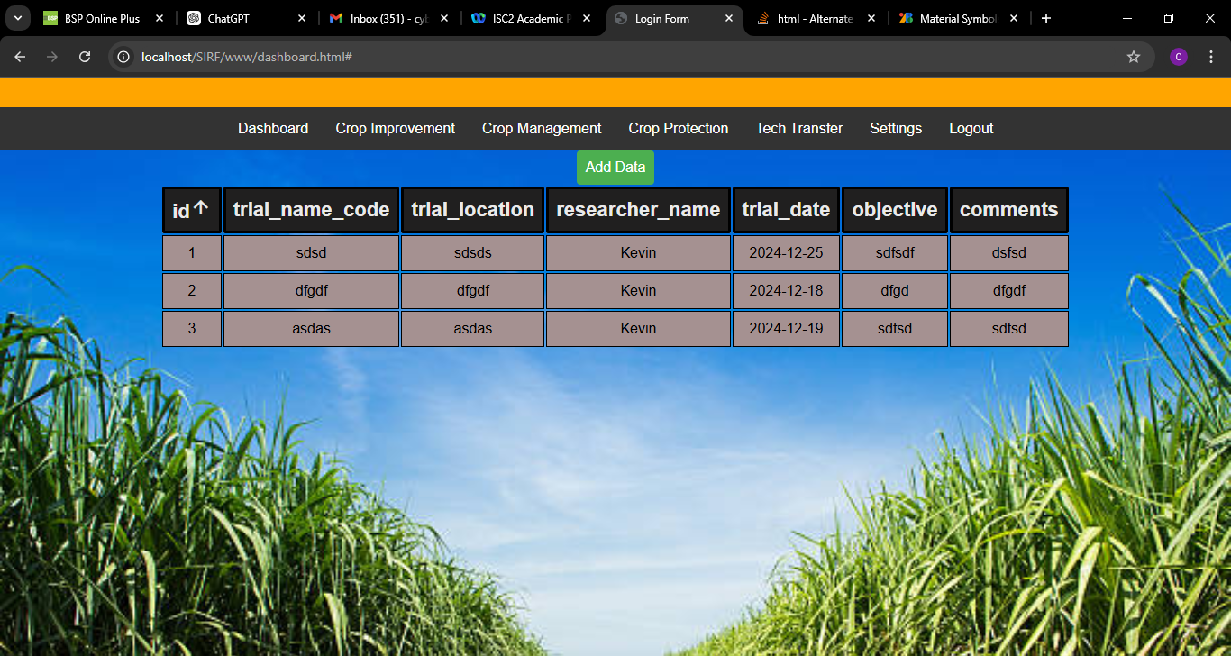

**Crop management** – Soil testing

Selection date and field location : should give all other fields in the report

