9 October 2025

Mr. Naulu Mataitini

Dear Sir,

RE: **CEASE AND DESIST - DEMAND**

1. We act for Pacific Polytech (“**our client**”).
2. We have been advised by our client that you have caused to be published a social media post entitled *“The Selective Microscope: Why is a Tertiary Scandal Worth a COI, but a $360M Cyclone Scandal is Not?”* containing defamatory statements against our client.
3. The post includes allegations suggesting that grants to Pacific Polytech were given to an “unaccredited” institution and implying improper or illegal conduct.
4. We have been provided with evidence of these materials, which are widely circulated and read in Fiji.
5. The statements in your post are false, malicious, and defamatory, particularly the suggestion that Pacific Polytech is “unaccredited”.
6. The Screenshot of the same is as follows:

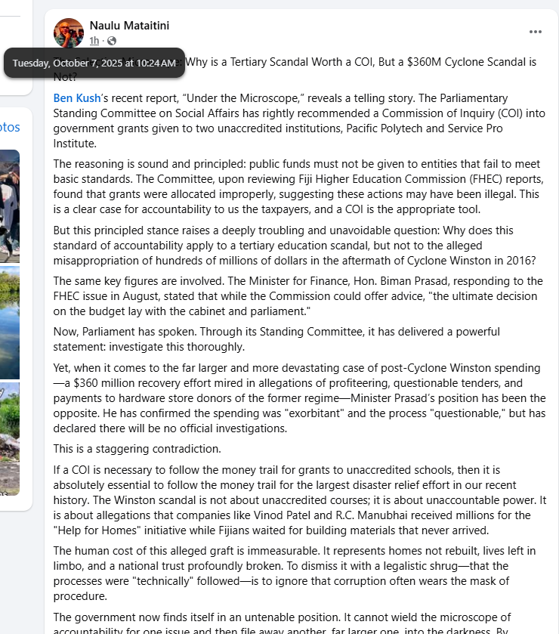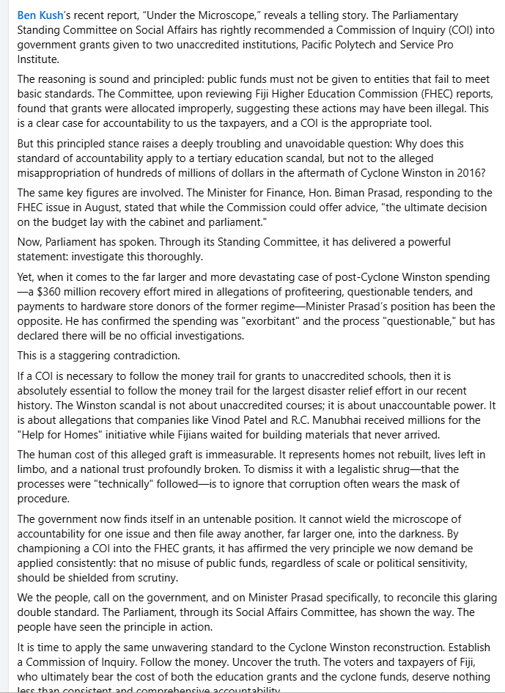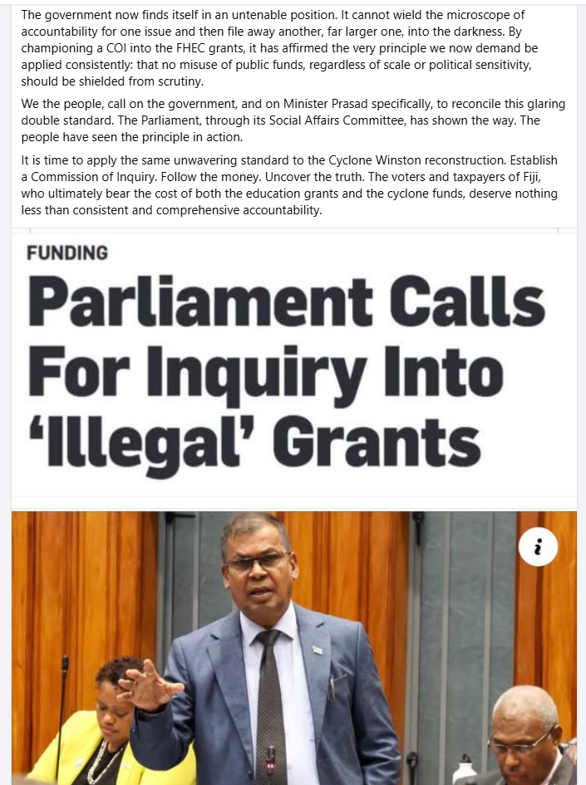

1. The posting and comments are publicly accessible on social media and have been viewed by many residents of Fiji. The statements have been made without any proof or evidence.
2. You are hereby **directed to Cease and Desist** further publication of any defamatory and malicious materials, posts or comments of our Client’s reputation.
3. Our client is a recognised educational entity by the government of Fiji and they are governed by and under the laws of Fiji where procedural and regulatory frameworks are established to be followed.
4. The posting on Facebook by you has disparaged, tarnished and damaged our client’s reputation, character and standing in the educational, social and business communities and organizations.
5. **TAKE NOTICE** that via this letter we on behalf of our client instruct and demand from you to immediately carry out the following:
6. **Cease and Desist** all publication of any defamatory and malicious posts against Pacific Polytech;
7. **Remove forthwith all posts** and comments against Pacific Polytech from social media;
8. **Publish a public apology** in the same forum, clearly stating that Pacific Polytech is accredited and that all allegations to the contrary are false;
9. **Cease and desist from any future publication** of defamatory or maliciousmaterial concerning Pacific Polytech;
10. **Pay FJD $500 legal cost** incurred by Pacific Polytech in issuing this notice;
11. **Provide proof of removal of the posts,** publication of your apology, and payment of the sums demanded within 7 days of receipt of this letter.
12. Should you fail to comply with the above, we hold firm instructions to institute **LEGAL ACTION AGAINST YOU WITHOUT ANY FURTHER WARNINGS** and in which case you will be penalized.
13. **We will use this letter as further evidence in Court seeking damages against you.**

Yours faithfully,

**KARUNARATNE LAWYERS**

……………………………………